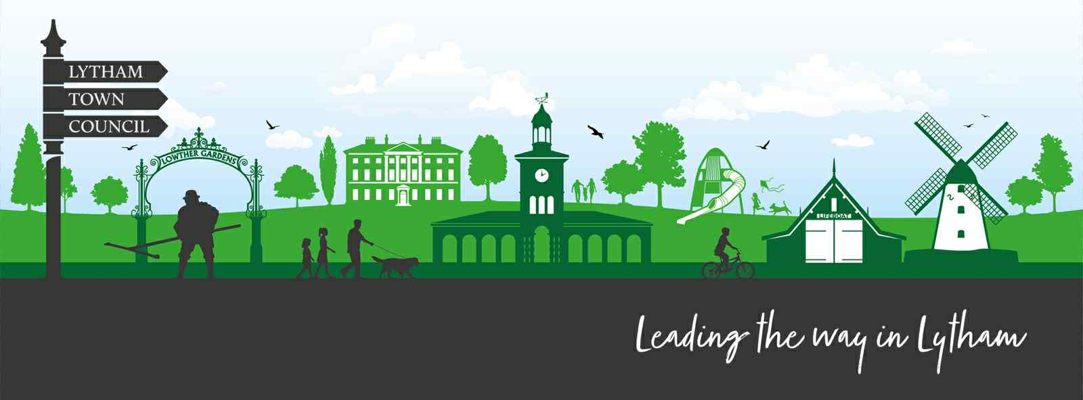
Lytham Town Council
c/o Lytham Institute
27 Clifton Street, Lytham, Lancashire. FY8 5EP
Email : Clerk@lythamtowncouncil.gov.uk
Web: www.lythamtowncouncil.gov.uk
Chair Cllr Simon Newell
Clerk: Mr Luke Russell

Lytham Town Council - Council Meeting

To: All members of Lytham Town Council.
You are hereby summoned to attend an Extraordinary Meeting of the Town Council to be held on Monday 13th April 2026 at 9:30am at the Lytham Institute, 27 Clifton Street, Lytham, Lancashire, FY8 5EP.
The rationale for calling this extraordinary meeting is to enable Council to consider and resolve the end of year accounts and completion of the Annual Governance and Accountability Return (AGAR) documentation to enable Internal Audit processes to be undertaken.
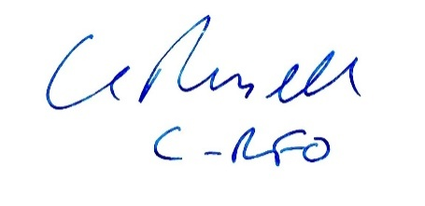
Mr Luke Russell MA
Clerk & Responsible Financial Officer
Wednesday 8th April 2026
Agenda
Extraordinary Meeting of Lytham Town Council
Monday 13th April 2026
- Welcome, introduction, Audio Recording notice and Health & Safety.  • The Clerk will then confirm Member attendance and provide apologies for absence where received & accepted | CRFO
- Nomination and Election of Chair for the meeting  (in the absence of the Chair of the Council) | Cllrs
3. Declarations of Interest and Dispensations  • Councillors to declare any interests in the agenda items.  • Consideration of requests for dispensations. | Cllrs
4. Public Participation (Open Forum)
(Max 15 minutes, 3 minutes per speaker)
• Members of the public may raise items with the Council in respect of the business on the agenda

The Chair may limit a member of the public to 3 minutes of speaking to ensure the smooth running of the meeting. Overall, the section will typically be limited to 15 minutes although the Chair, may at their discretion, extend this.

5. Finance and Governance  - To note the end of financial year Statement of Accounts  - To consider and resolve the motion:  Decision item  - Proposal: To approve the completion of the Annual Governance and Accountability Return (AGAR) Form 3, Section 2 – Accounting Statements.  - Legal Basis: Accounts and Audit Regulations 2015 (SI 2015/234); Local Government Act 1972 s151. Financial Regulations: Section 3. | Clerk / RFO report circulated  Cllrs.
14. Date, Time & Location of Next Meeting
• Wednesday 29th April 2026
6:30pm
Lytham Institute, 27 Clifton Street, Lytham, Lancashire, FY8 5EP
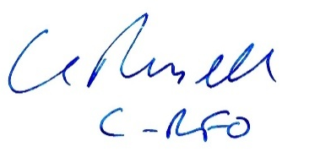
Clerk’s Signature: Date: Wednesday 8th April 2026

